PRICE LIST

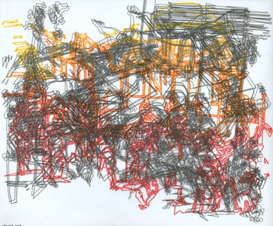 | Marjorie Van Cura  Untitled 0724, 2024  permanent marker and Ink on translucent film  14 x 17 in  (MVC012) | $ 3,300
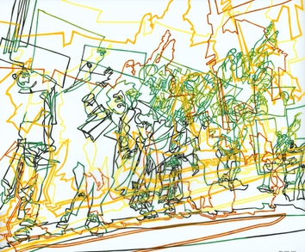 | Marjorie Van Cura  Untitled 0123, 2023  ink on translucent film  14 x 17 in  (MVC001) | $ 3,300
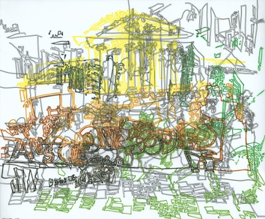 | Marjorie Van Cura  Untitled 0623, 2023  permanent marker and ink on translucent film  14 x 17 in  (MVC009) | $ 3,300
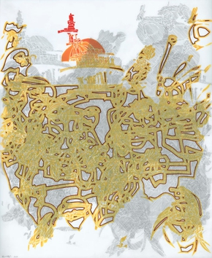 | Marjorie Van Cura  Untitled 0521, 2021  graphite and ink on translucent film  17 x 14 in  (MVC006) | $ 3,300
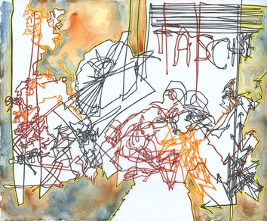 | Marjorie Van Cura  Untitled 0224, 2024  ink on translucent film  14 x 17 in  (MVC003) | $ 3,300
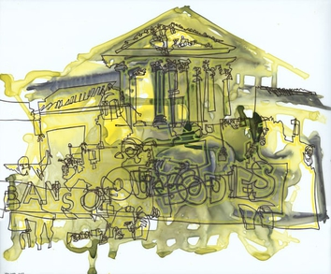 | Marjorie Van Cura  Untitled 0423, 2023  ink on translucent film  14 x 17 in  (MVC005) | $ 3,300
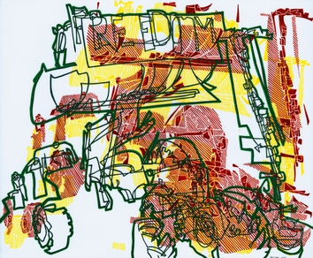 | Marjorie Van Cura  Untitled 0522, 2022  ink on translucent film  14 x 17 in  (MVC007) | $ 3,300
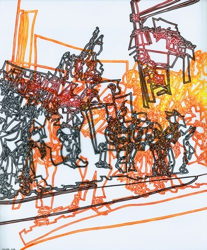 | Marjorie Van Cura  Untitled 0822, 2022  ink on translucent film  17 x 14 in  (MVC013) | $ 3,300
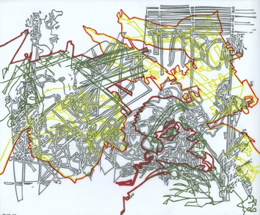 | Marjorie Van Cura  Untitled 0324, 2024  graphite and ink on translucent film  14 x 17 in  (MVC004) | $ 3,300
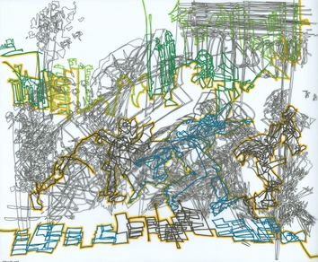 | Marjorie Van Cura  Untitled 0124, 2024  permanent marker and ink on translucent film  14 x 17 in  (MVC002) | $ 3,300
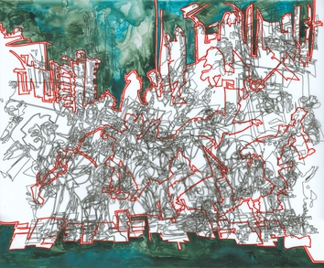 | Marjorie Van Cura  Untitled 0723, 2023  permanent marker and ink on translucent film  14 x 17 in.  (MVC011) | $ 3,300
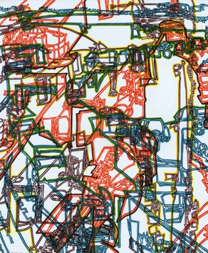 | Marjorie Van Cura  Untitled 0722, 2022  ink on translucent film  17 x 14 in  (MVC010) | $ 3,300
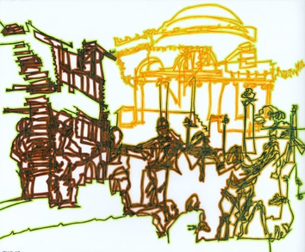 | Marjorie Van Cura  Untitled 0524, 2024  ink on translucent film  14 x 17 in  (MVC008) | $ 3,300

