PRICE LIST: Sandy Litchfield

 | Sandy Litchfield b. 1966  Lingerlin, 2024  signed on back  gouache, pastel and colored pencil on paper  30 x 22 in.  (SLI198) | $ 4,700
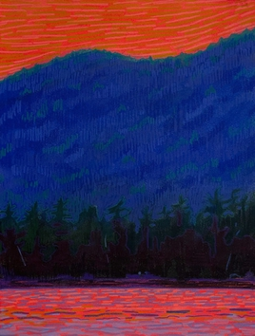 | Sandy Litchfield b. 1966  Fire Sky, 2024  signed on back  gouache, pastel and colored pencil on paper  16 x 12 in.  (SLI200) | $ 1,600
 | Sandy Litchfield b. 1966  Latent, 2024  signed on back  gouache, pastel and colored pencil on paper  16 x 12 in.  (SLI201) | $ 1,600
 | Sandy Litchfield b. 1966  Lake Ling, 2024  signed on back  gouache, pastel and colored pencil on paper  16 x 12 in.  (SLI202) | $ 1,600
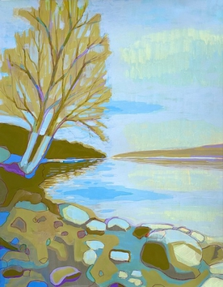 | Sandy Litchfield b. 1966  Low Reservoir, 2021  Gouache and colored pencil on paper  18.0h x 14.0w in  45.72h x 35.56w cm  (SLI088) | $ 1,200
 | Sandy Litchfield b. 1966  Last Light, 2025  signed on back  gouache, pastel and colored pencil on paper  9 x 10 in.  (SLI199) | $ 1,100
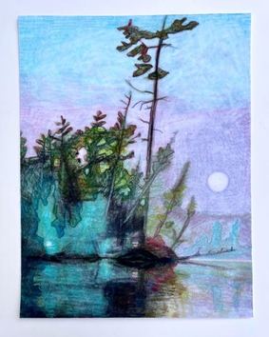 | Sandy Litchfield b. 1966  Lake 1 (kayak), 2021  Colored pencil on velour paper  11.0h x 9.0w in  27.94h x 21.59w cm  (SLI131) | $ 850
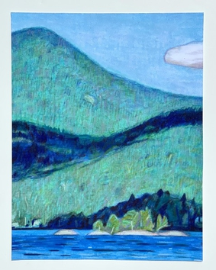 | Sandy Litchfield b. 1966  Lake 7 (cloud shadows), 2021  Colored pencil on velour paper  11.0h x 9.0w in  27.94h x 21.59w cm  (SLI136) | $ 600
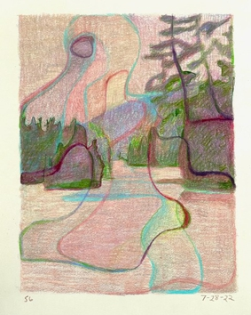 | Sandy Litchfield b. 1966  7-28-22, 2022  Colored pencil on paper  Image: 9 x 7 in. Paper: 11 x 8.5 in.  (SLI140) | $ 500
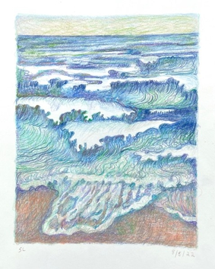 | Sandy Litchfield b. 1966  8-8-22 Gay Head, 2022  initialed lower left "SL" signed on back "Sandy Litchfield" and titled "Gay Head 2022"  Colored pencil on paper  Image: 9 x 7 in. Paper: 11 x 8.5 in.  (SLI144) | $ 500
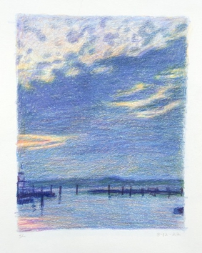 | Sandy Litchfield b. 1966  8-12-22, 2022  Colored pencil on paper  Image: 9 x 7 in. Paper: 11 x 8.5 in.  (SLI147) | $ 500
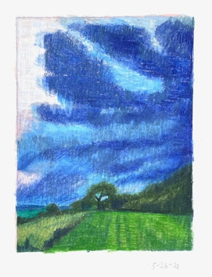 | Sandy Litchfield b. 1966  5-26-21, 2021  Initialed "SL" lower left and dated "5-26-21" lower right titled on back "Mt. Polllux"  Colored pencil on paper  paper: 10.25 x 8.25 in. image: 8 x 6 in.  (SLI174) | $ 500
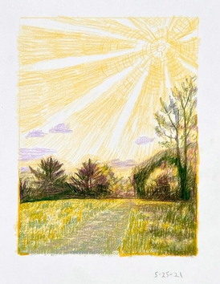 | Sandy Litchfield b. 1966  5-25-21, 2021  initialed lower left "SL" and dated lower right "5-25-21" titled "Mt. Pollux" on back  Colored pencil on paper  paper: 10.5 x 8.25 in. image: 8 x 6 in.  (SLI175) | $ 500
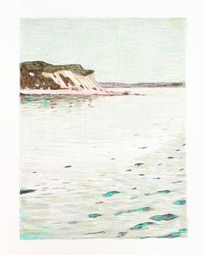 | Sandy Litchfield b. 1966  8-11-21, 2021  dated "8-11-21" lower right signed and titled on back "Sailing 2021" Sandy Litchfield  Colored pencil on paper  paper: 10.5 x 8.5 in. image: 8 x 6 in.  (SLI178) | $ 500

